1. **What does a system represent? Component of a system with example?**

A system is defined as a group of objects that are joined together in some regular interaction or interdependence toward the accomplishment of some purpose**.**

Components of a System:

• Entity- … An object of interest in the system: Machines in factory

• Attribute- … The property of an entity: speed, capacity

• Activity- … A time period of specified length: welding, stamping

• State- … A collection of variables that describe the system in any time: status of machine (busy, idle, down…) 19 Components of a System

• Event-… An instantaneous occurrence that might change the state of the system: breakdown.

• Endogenous- … Activities and events occurring with the system.

• Exogenous-… Activities and events occurring with the environment.

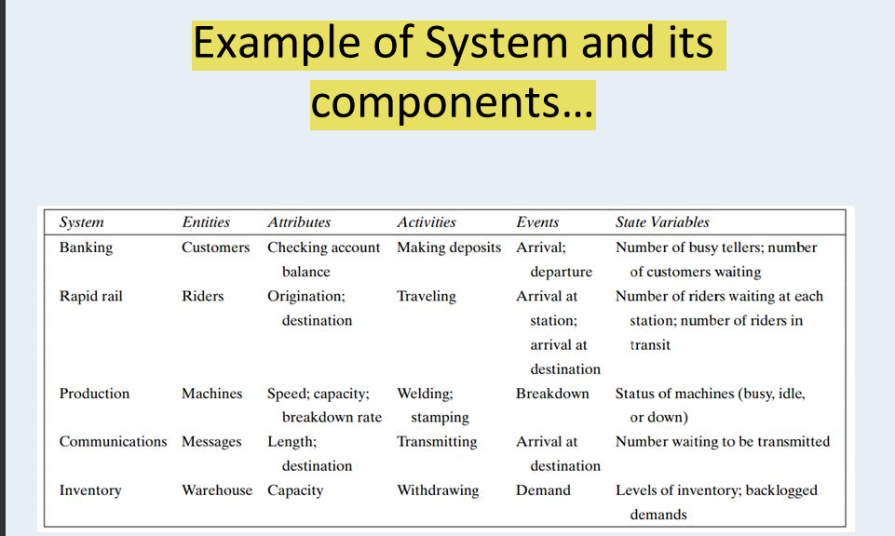

1. **Why is it necessary to decide on th boundary between system & its environment?**

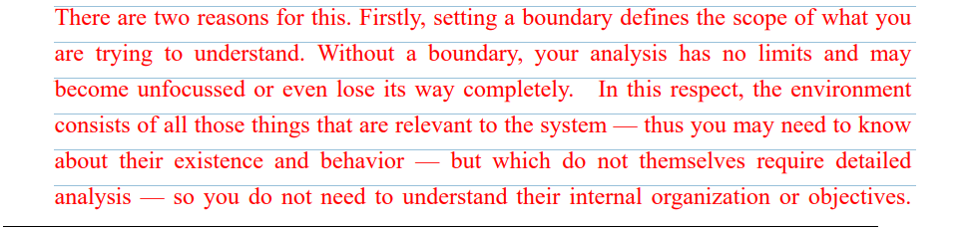

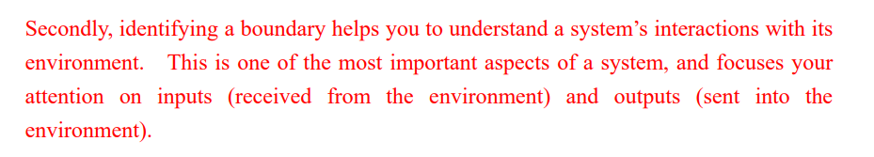

1. **what type of simulation implemented in augmented reality**
2. **Is it possible to simulate a system without modeling an entity from outside the boundary of the system?**
3. **Compare live,Virtual & constractive simulation with example?**

**Live** - A simulation involving real people operating ***real systems***. Military training events using real equipment are live simulations. ***They are considered simulations because they are not conducted against a live enemy.***

**Virtual** - A simulation involving real people operating ***simulated systems*.** Virtual simulations inject a Human-in-the-Loop into a central role by ***exercising motor control skills, decision making skills, or communication skills***

**Constructive** - A simulation involving ***simulated people operating simulated systems***. Real people stimulate (make inputs to) such simulations, but are not involved in determining the outcomes. ***A constructive simulation is a computer program.*** For example, a military user may input data instructing a unit to move and to engage an enemy target. The constructive simulation determines the speed of movement, the effect of the engagement with the enemy and any battle damage that may occur.

1. **Note down the step of simulation with appropriate flowchart**

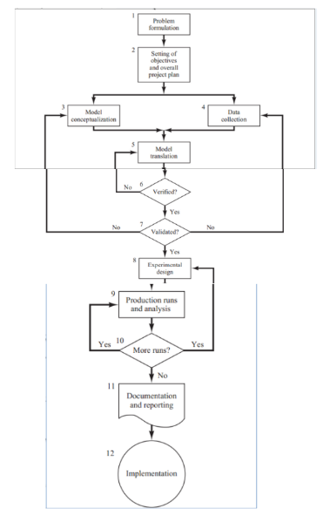

**7(a).** **Discuss the situation when simulation is a not an appropriate tool.**

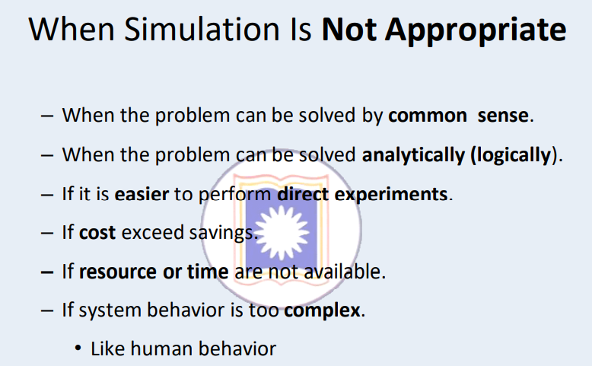

**7(B).** **Discuss the situation when simulation is an appropriate tool.**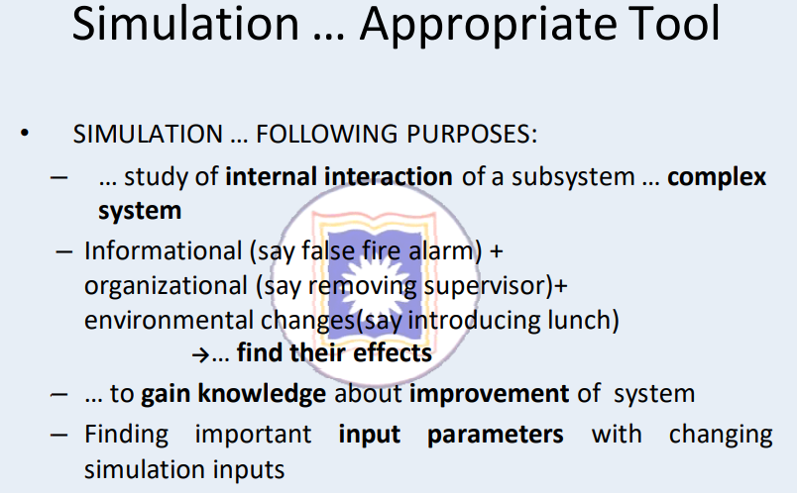

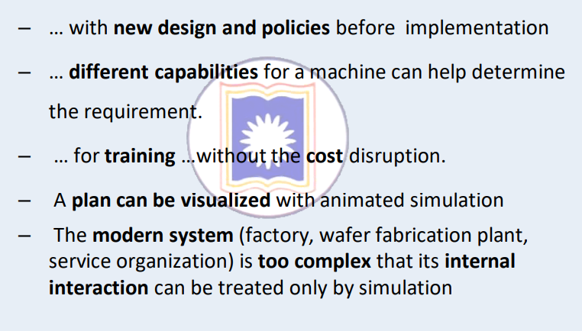

**8. Define system & model? Note different type of model?**

Model: It construct a conceptual framework that describes a system. It is necessary to consider those accepts of systems that affect the problem under investigation. It helps analyst to predict the effect of the change of system.

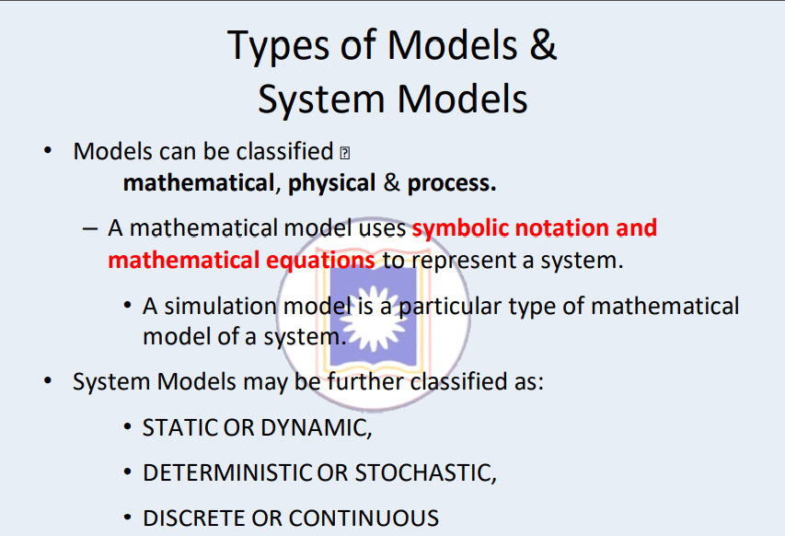

**9. Define attribute entity activities with real life example?**

**See 1**

**10**. **How simulation improves our lives?**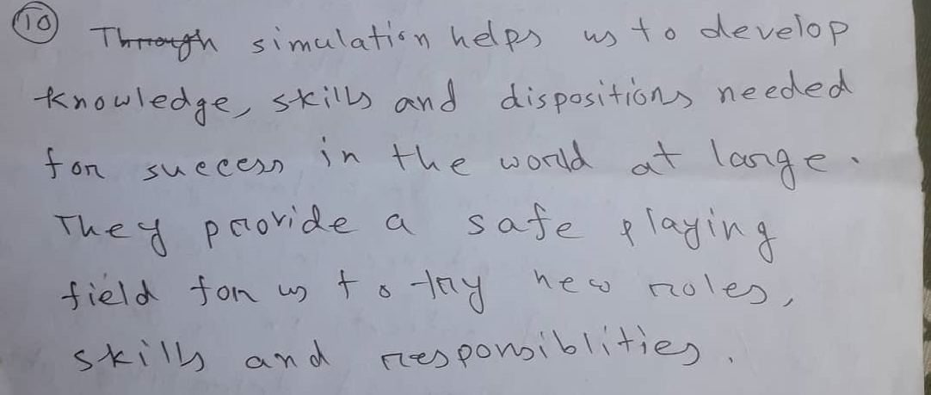

**11.Explain Discrete Event Simulation & Continuous-event simulation?**

**Discrete Event Simulation:** Discrete event simulation (DES) is the process of codifying the behavior of a complex system as an ordered sequence of well-defined events. In this context, an event comprises a specific change in the system's state at a specific point in time. Common applications of DES include stress testing, evaluating potential financial investments, and modeling procedures and processes in various industries, such as manufacturing and healthcare.

**Continuous-event simulation:** n continuous simulations, certain state variables (or states of simulation objects represented by real-valued attributes) change continuously, as modeled by differential equations. Two prominent general approaches to continuous simulation are: System Dynamics and Equation-Based Object-Oriented Modelling with Modelica

**12.** **Mention the properties of randorm number? Use of random numbers.**

A random number is a number generated by a process, • whose outcome is unpredictable, • and which cannot be sub sequentially reliably reproduced.

A sequence of random numbers, R1, R2, R3 must have two important properties:

1. Uniformity-they are equally probable every where
2. Independence-the current value of a random variable has no relation with the previous values

